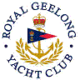 | Royal Geelong Yacht Club Inc.  Est 1859
Trophy Deed of Gift.

Trophy: | Bay Aggregate Championship: Cadet
Presented by:
Date: | 1969
For: | Port Phillip Fleet
Remarks / Revisions

